

Jazzcash Ecofactory Manual Technical Document

V1

Document Control

|  |  |  |  |
| --- | --- | --- | --- |
| # | Name | Changes | By |
|  |  |  |  |
| 1 | Eco System Factory | Initial Version | Arcana Team |

# Introduction

Currently any corporate clients that use our payments services, they come onboard through a long and slow manual onboarding & integration process. The whole process is completely dependent on manpower and requires a lot of emails, prioritization & paper work before a client goes live. The purpose of this document is to digitize this end to end process and ensure that clients can come onboarded with minimum or zero human intervention.

# Objective

The purpose of this document is to describe business requirement for Ecosystem factory platform development.

# Components

## Portal

Onboarding & account opening - will be referred as “PORTAL”.

* **Homepage**
* Whenever a user enters the URL, it will be redirected to the Homepage.
* User can view and read the stuff available and their information.
* User can find the right solutions for their business needs.
* Tutorial videos are available for the users.
* User can create a JazzCash account.
* It shows all the sponsors of JazzCash Transaction.
* It has a community blog.
* Those users who have administrative rights, they can edit/upload/delete or change the videos and images published on the platform.

**Regions**

**Home Page Banner**

For the addition of home page banner go to “/node/add”

Select “Jazz Site Banner” content type

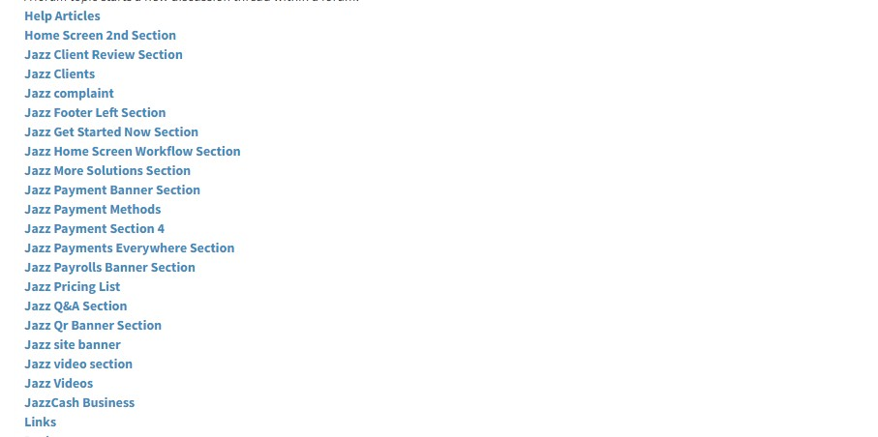

For existing node edit go to “/admin/content”

Select “Jazz Site Banner” in content types and filter it Edit its node.

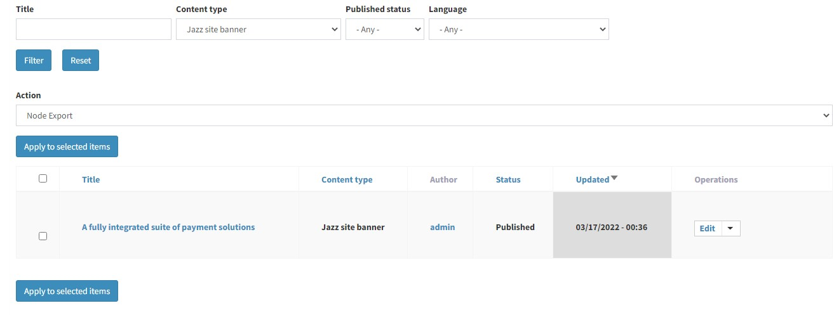

**Jazz Home Screen 2nd Section**

For the addition of home page 2nd Section go to “/node/add”

Select “Home Screen 2nd Section” content type



For existing node edit go to “/admin/content”

Select “Home Screen 2nd Section” in content types and filter it Edit its nodes.

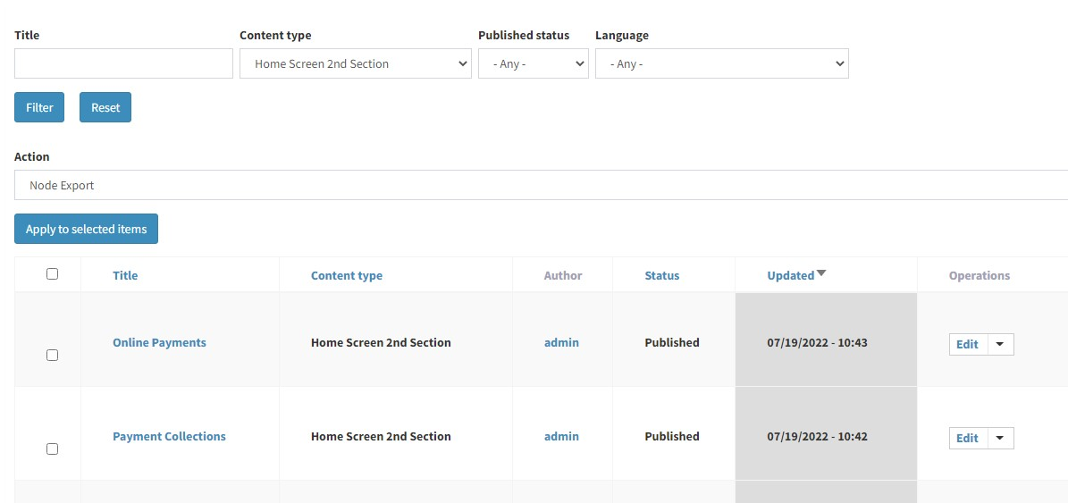

**Jazz Payment Methods**

For the addition of jazz payment methods Section go to “/node/add”

Select “Jazz Payment Methods” content type



For existing node edit go to “/admin/content”

Select “Jazz Payment Methods” in content types and filter it Edit its nodes.

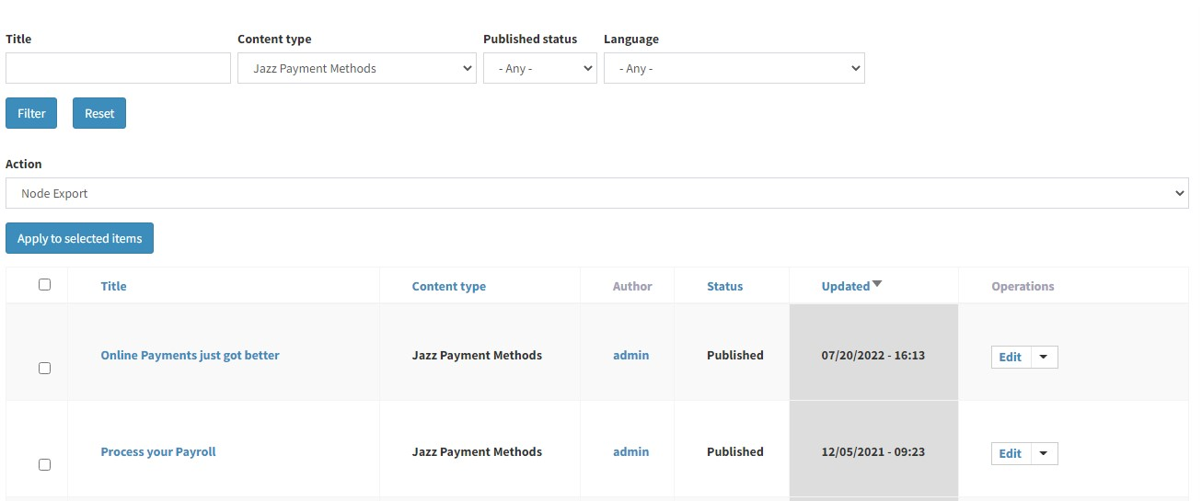

**Jazz Workflow Section**

For the addition of jazz workflow go to “/node/add”

Select “Jazz Home Screen Workflow Section” content type



For existing node edit go to “/admin/content” Select “Jazz Payment Methods” in content types and filter it Edit its node.

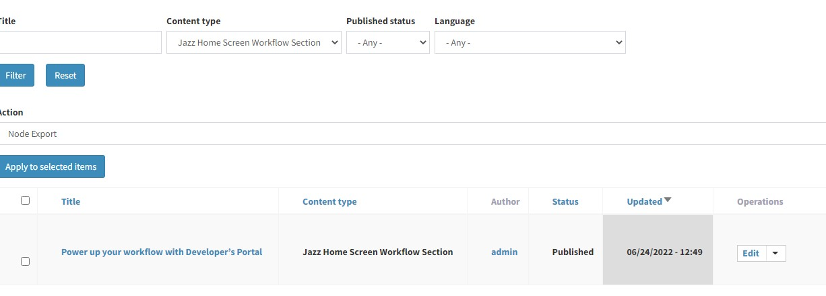

**Jazz Videos Section**

For the addition of jazz videos Section go to “/node/add”

Select “Jazz Videos” content type



For existing node edit go to “/admin/content”

Select “Jazz Videos” in content types and filter it Edit its node.

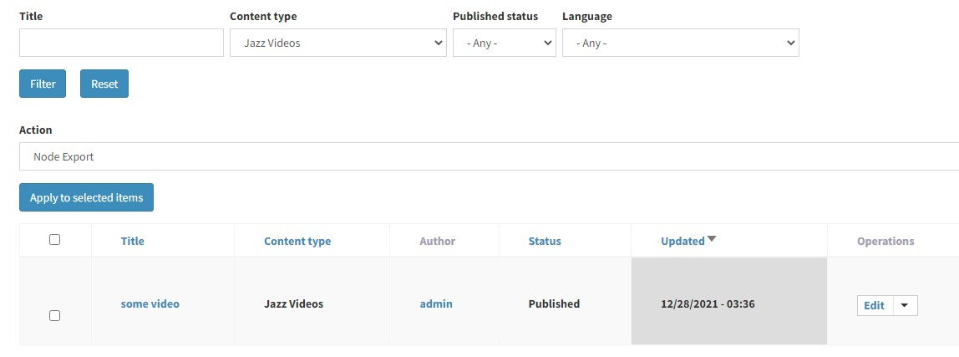

**Jazz Business Section**

For the addition of jazz business Section go to “/node/add”

Select “JazzCash Business” content type



For existing node edit go to “/admin/content”

Select “JazzCash Business” in content types and filter it

Edit its node.

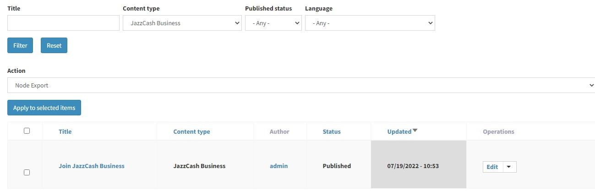

**Jazz Clients Section**

For the addition of jazz clients Section go to “/node/add”

Select “Jazz Clients” content type



For existing node edit go to “/admin/content” Select “Jazz Client” in content types and filter it

Edit its nodes.

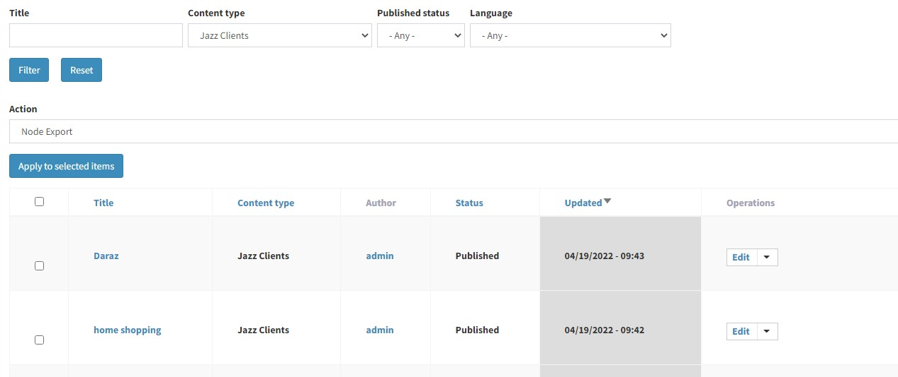

**Jazz Clients Review Section**

For the addition of jazz clients review Section go to “/node/add”

Select “Jazz Client Review Section” content type



For existing node edit go to “/admin/content”

Select “Jazz Client Review Section” in content types and filter it

Edit its nodes.

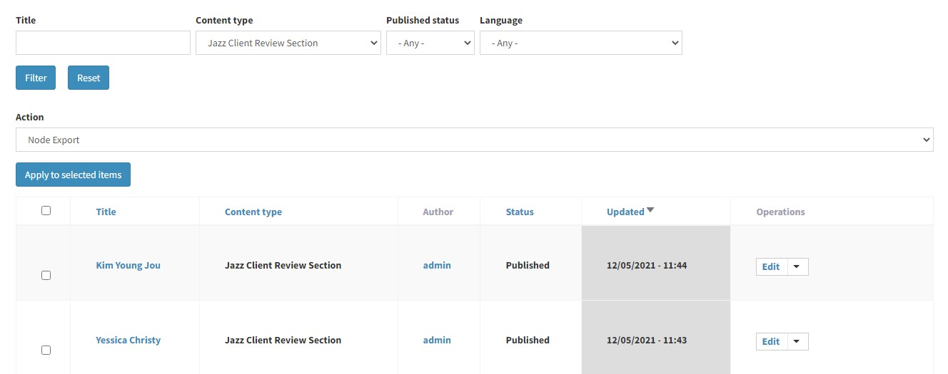

**Payment**

* Users can create an account to accept the online payments.
* Users can access their funds quickly.
* Users can build their own checkout experience using our customizable widget and Merchant API.
* It shows the Transaction Type and MDR
* Users can Sign up for JazzCash Business, Submit Application, Start Accepting Payments.
* It shows some FAQs.
* It shows more solutions Payment Collection, Payroll Services, QR Payments.

* **Online Payments, Payment Collection, Payrolls** and **QR payments:** thesepages are API Integrated pages, they show their own Pricing Details and FAQs.

**Payments Page Regions**

**Jazz Payment Section Banner**

For the addition of jazz payment Section banner go to “/node/add”

Select “Jazz Payment Banner Section” content type



For existing node edit go to “/admin/content”

Select “Jazz Payment Banner Section” in content types and filter it

Edit its nodes

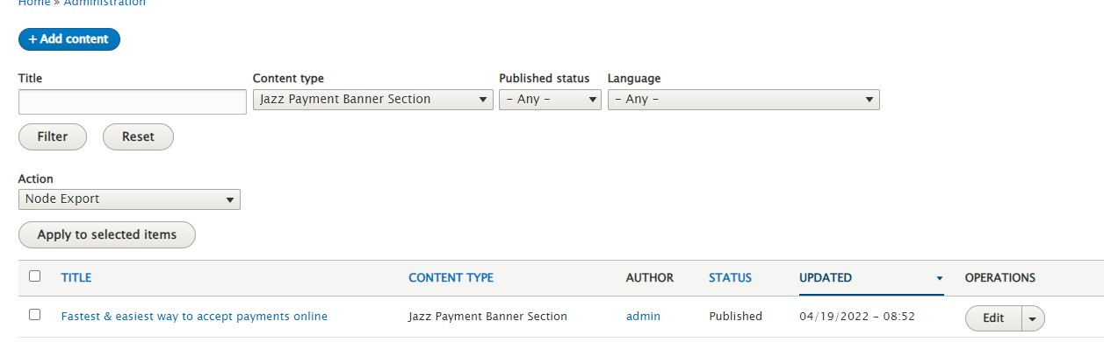

**Jazz Payment Everywhere Section**

For the addition of Jazz payment everywhere Section go to “/node/add”

Select “Jazz Payments Everywhere Section” content type



For existing node edit go to “/admin/content”

Select “Jazz Payments Everywhere Section” in content types and filter it

Edit its nodes

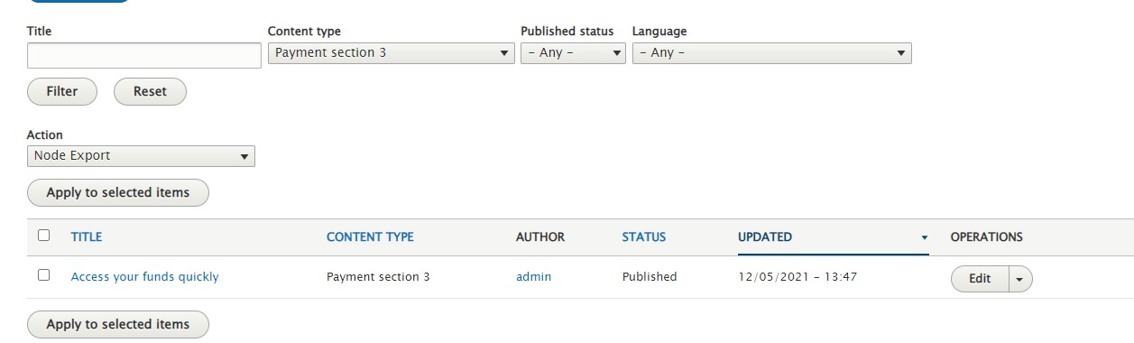

**Jazz Payment Third Section**

For the addition of Jazz payment third Section go to “/node/add”

Select “Payment Section 3” content type

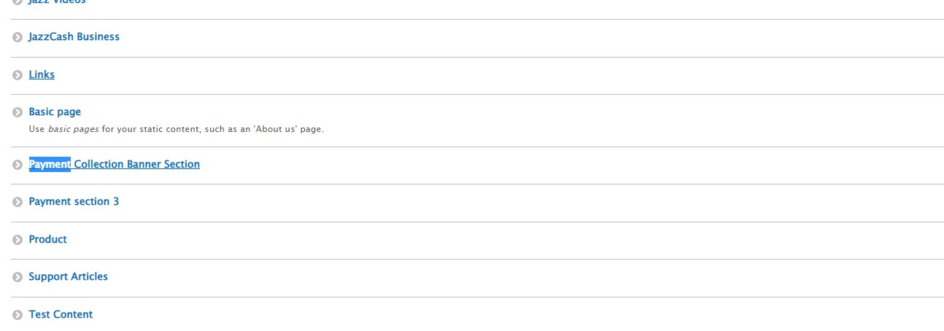

For existing node edit go to “/admin/content”

Select “Payment Section 3” in content types and filter it

Edit its nodes



**Jazz Payment Fourth Section**

For the addition of Jazz Payment Fourth Section go to “/node/add”

Select “Jazz Payment Section 4” content type



For existing node edit go to “/admin/content”

Select “Jazz Payment Section 4” in content types and filter it

Edit its nodes

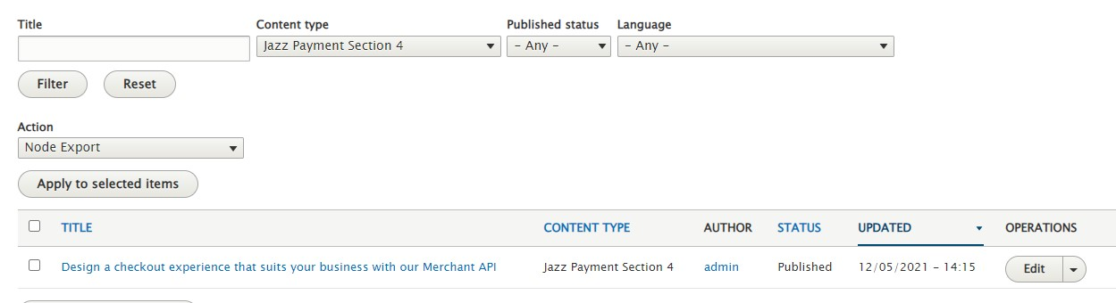

**Jazz Pricing List Section**

For the addition of Jazz Pricing List Section go to “/node/add”

Select “Payment Pricing List” content type



For existing node edit go to “/admin/content”

Select “Jazz Pricing List” in content types and filter it

Edit its nodes

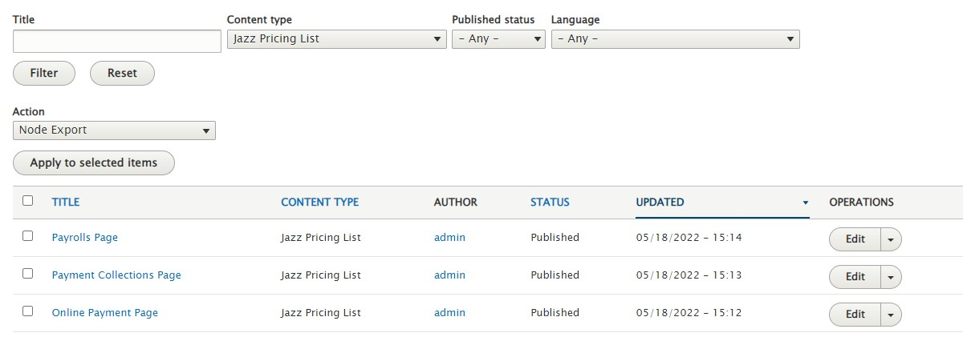

**Jazz Get Started Now Section**

For the addition of Jazz Get Started Now Section go to “/node/add”

Select “Payment Get Started Now Section” content type



For existing node edit go to “/admin/content”

Select “Jazz Get Started Now Section” in content types and filter it

Edit its nodes

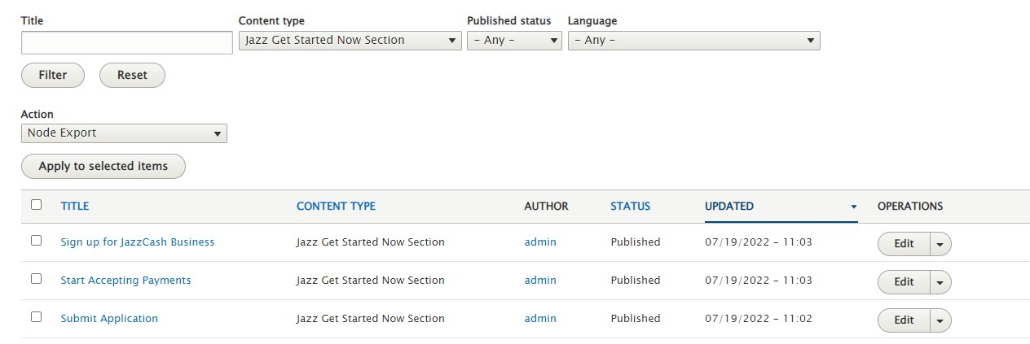

**Jazzcash Business Section**

For the addition of Jazzcash Business Section go to “/node/add”

Select “JazzCash Business” content type



For existing node edit go to “/admin/content”

Select “JazzCash Business” in content types and filter it

Edit its nodes

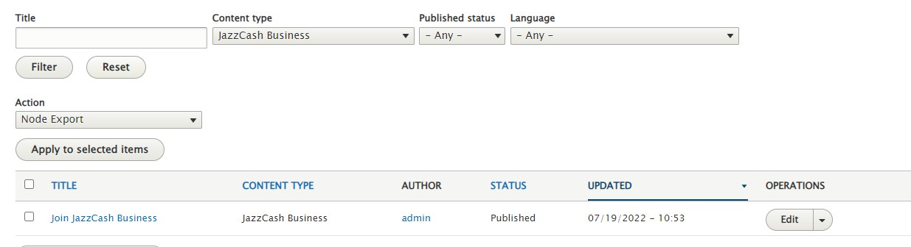

**Jazz QA Section**

For the addition of Jazz QA Section go to “/node/add”

Select “Payment Q&A Section” content type



For existing node edit go to “/admin/content”

Select “Jazz Q&A Section” in content types and filter it

Edit its nodes

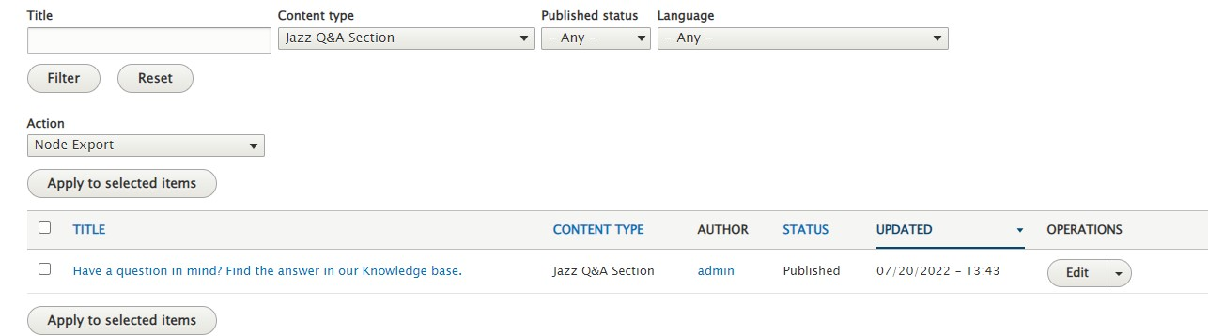

**Jazz More Solutions Section**

For the addition of Jazz More Solutions Section go to “/node/add”

Select “Jazz More Solutions Section” content type



For existing node edit go to “/admin/content”

Select “Jazz More Solutions Section” in content types and filter it.

Edit its nodes

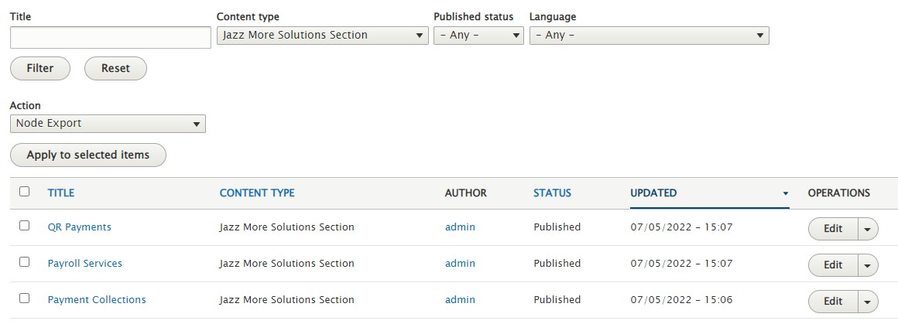

**Jazz Payment Collection Banner**

For the addition of Jazz Payment Collection Banner Section go to “/node/add”

Select “Payment Collection Banner Section” content type

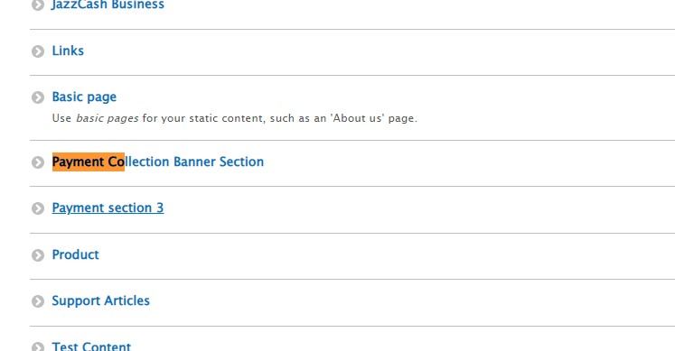

For existing node edit go to “/admin/content”

Select “Payment Collection Banner Section” in content types and filter it

Edit its nodes

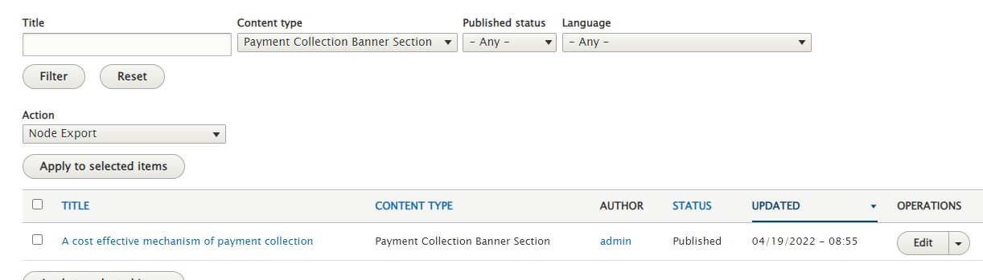

**Jazz Payroll Banner**

For the addition of Jazz Payrolls Banner Section go to “/node/add”

Select “Payment Payrolls Banner Section” content type



For existing node edit go to “/admin/content”

Select “Jazz Payrolls Banner Section” in content types and filter it

Edit its nodes

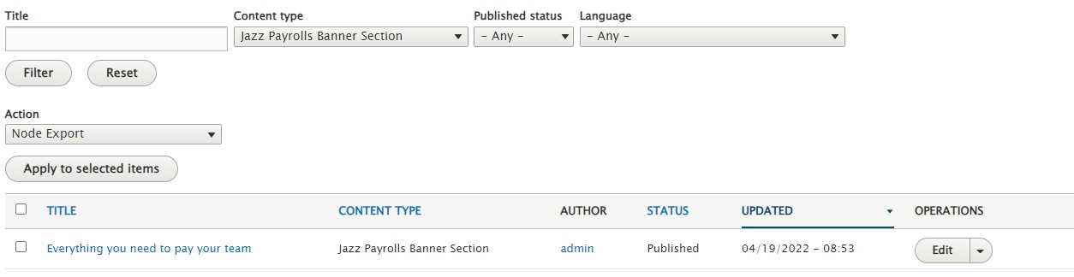

**Jazz QR Banner**

For the addition of Jazz QR Banner Section go to “/node/add”

Select “Payment QR Banner Section” content type



For existing node edit go to “/admin/content”

Select “Jazz QR Banner Section” in content types and filter it

Edit its nodes

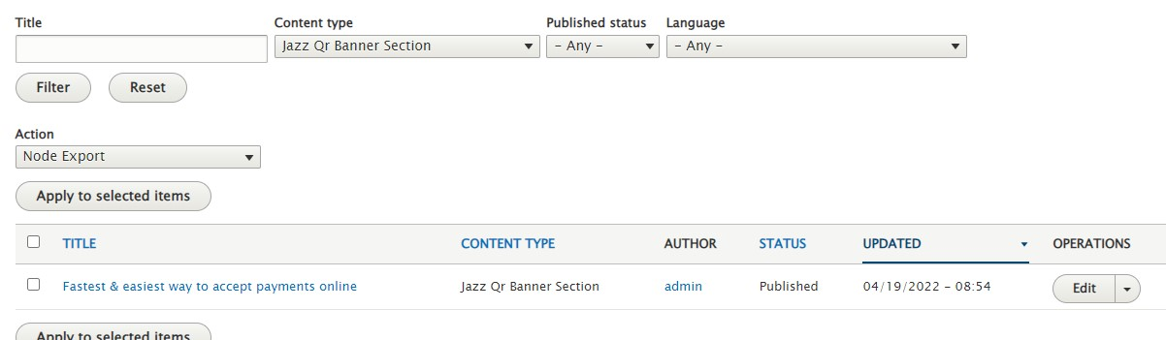

* **How Can We Help You?**
* Users can search anything in which they face problems
* User can get the solution about payment problems, account problems etc.

* **Jazz Community**
* It provides a fully integrated suite of payment solutions
* User can discuss and ask the related questions
* It shows Top discussions and Recent discussions

* **Blogs**
* User can blog filter blocks by selecting guides filter, popular filter, more filter.
* It displays all the three filters guides, popular and more.

For the addition of Jazz Blogs go to “/node/add”

Select “Blogs” content type

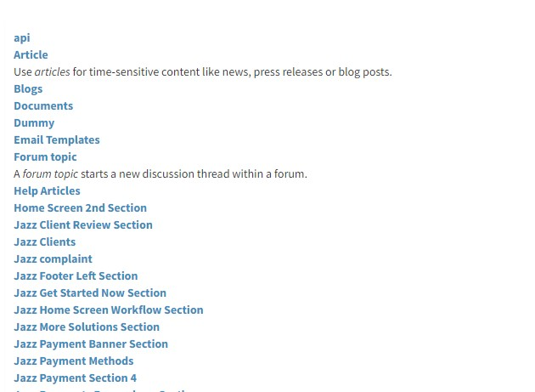

For existing node edit go to “/admin/content”

Select “Blogs” in content types and filter it

Edit its nodes

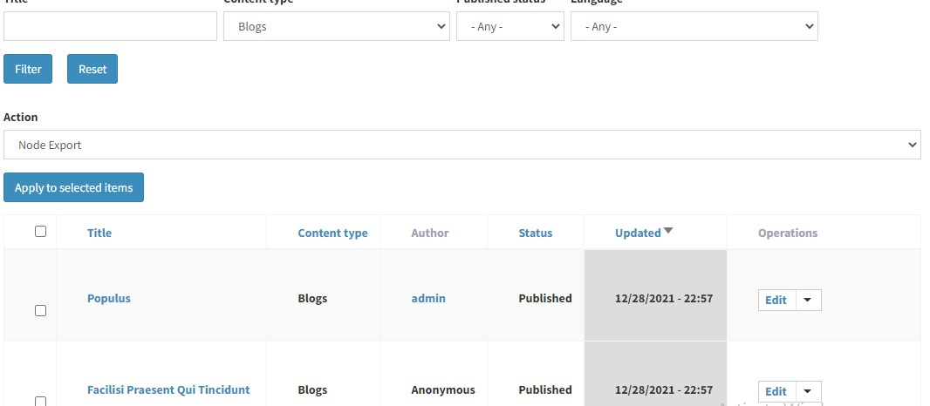

* **Complaint**
* Users can write the complaint if they are facing some problems or issues.
* User have to write his/her Full name, Company name, Complaint type (technical/financial), Select the priority of complaint, and type the message then save.

* **User Menu**

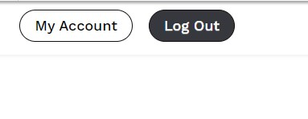

For changing user menu items go to “/admin/structure/menu”

Select “User Account Menu”

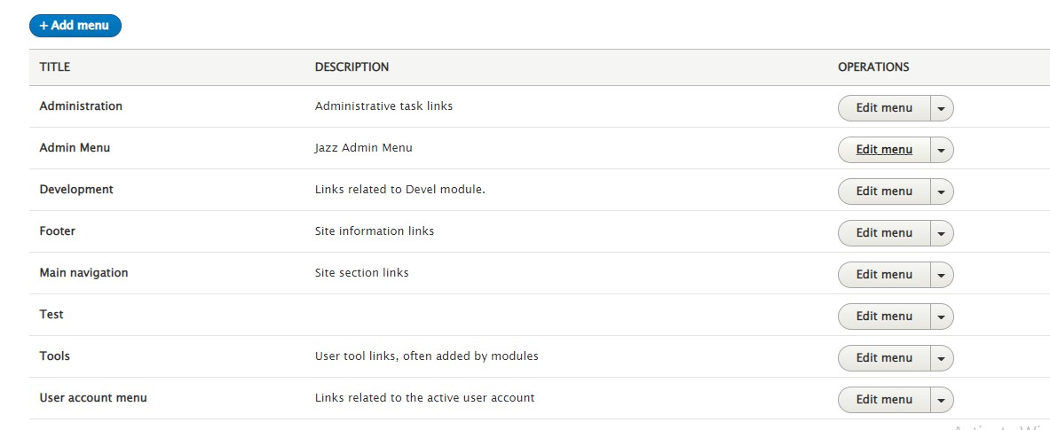

It Contains the following items

**My Account**

* **Users** can view their account details such as name, contact number and email address.
* It displays user’s different statuses like:
* Business Information
* Director’s Information
* Technology person of contact
* Authorized personnel details
* Bank approval details

* It displays different certificates statuses.

**Login**

* Enter username and password if you have already an account

**Sign In**

* Enter username and password if you have already an account

* **Site Menu**

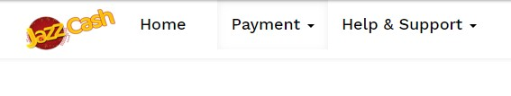

For changing site menu items go to “/admin/structure/menu” Select “Main Navigation”



**Admin Menu**

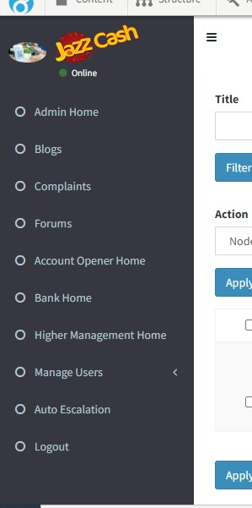

For changing admin menu items go to “/admin/structure/menu”

Select “Admin Menu”



## Admin

* **Homepage**
* Whenever a user enters the URL, it will be redirected to the Homepage of Portal’s Administration.
* On the left side, it shows a dashboard where all the pages are displayed.
* On the right side, it shows all the related content about the pages.

* **Admin Home**
* It displays a graph of Recent Traffic of Ecosystem Portal, On the x-axis it shows the user-data request status (Approved, New, Hold, Mark Discrepant) and on the y-axis it shows the number of viewers.
* Showing the statuses of all the requests, Ticket Statuses, CMSSection.

* **Blogs**
* it displays all the blog details, blog title, date and Blog type.

* **Complaints**
* It shows all the details about complaints that will be reported by the user.

For changing in complaint view go to “/admin/structure/view”

Edit “Complaints View”

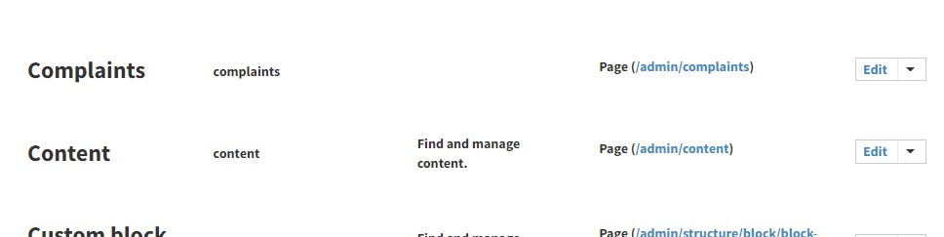

* **Forums**
* Display all the Forum details (Title, body, Forums category, Custom Text)

For changing in Admin Forums view go to “/admin/structure/view”

Edit “Admin Forums View”

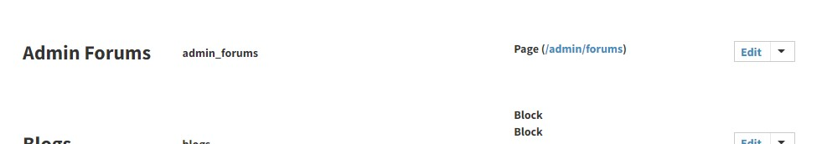

* **Account Opener Home**
* **Bank Home**
* **Business Home**

* **Manage User**
* Account Opener Approval
* Bank Account Approval
* Business Account Approval

For changing in manage users view go to “/admin/structure/view”

Edit “Admin Forums View”

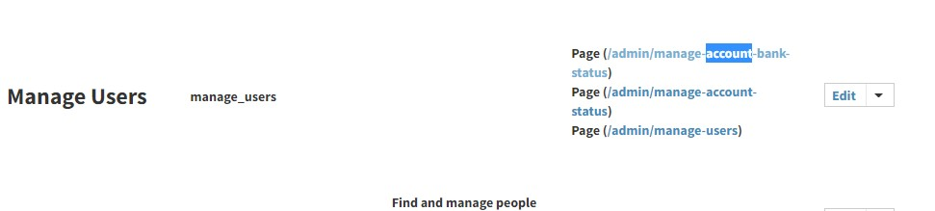

* **Auto Escalation**
* **Logout**